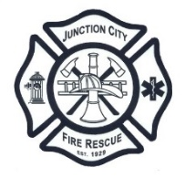

# Junction City Rural Fire Protection District

# Board of Directors Meeting

## Date: February 19, 2025

## Time: 6:30 p.m.

## Location: 1755 Juniper Street - Station 31

## Junction City OR 97448

### Agenda

### Call Meeting to Order

### Pledge of Allegiance

### Changes to the Agenda

### Public Comment

### Approval of Minutes – January 22, 2025

### Old Business

### Station Projects Update

### Legislative Update

* Streamline Website
* Apparatus Update

### New Business

### Appoint Budget Officer FY 2025-2026

### Adopt Budget Calendar FY 2025-2026

### Fire Chief Evaluation

### Fire Chief Report

### Monthly Run Stats

### Training Report

### Other Business

### Financial Report

### Expense/Revenue Reports

### Approval of Bills

### Adjournment

### Next Regular Meeting: March 19, 2025, at 6:30pm

### Location: 1755 Juniper Street, Junction City, OR

*To attend this meeting virtually or by telephone, please contact Fire Chief, Brandon Nicol (541) 998-2022 at least one hour before the meeting to obtain instructions on how to log in/call in.*